*Negative numbers game*

*This is an activity for two pupils.*

*They will require one copy of the Negative numbers board and a paper clip.*

*The teacher may need to explain the rules to some pupils.*

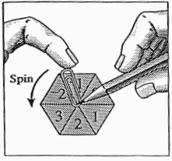

*You need:* Negative numbers board and a paperclip.

The rules

• Both players start at the start line.

• Decide who goes first.

The 2nd player chooses which lane he/she wants. (Do not change lanes.)

Players take it in turns to spin both spinners using a paperclip. They can choose to add or subtract the numbers on the two spinners.

If the total score is positive the player moves forward (clockwise).

If the total score is negative, the player moves backwards (anti-clockwise).

•The winner is the first player to complete a lap of the track.

• Players must obey instructions on the track

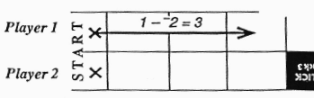

•

Players mark their progress and calculations on the track. Player 1 spins I and -2 and decides to subtract the numbers.

The calculation is shown above the arrow showing the move of three squares.

